**Python Programming for Machine Learning**

**Name: V.PARKAUV**

**Class: ECE ’C’**

**Roll Number: 220801143**

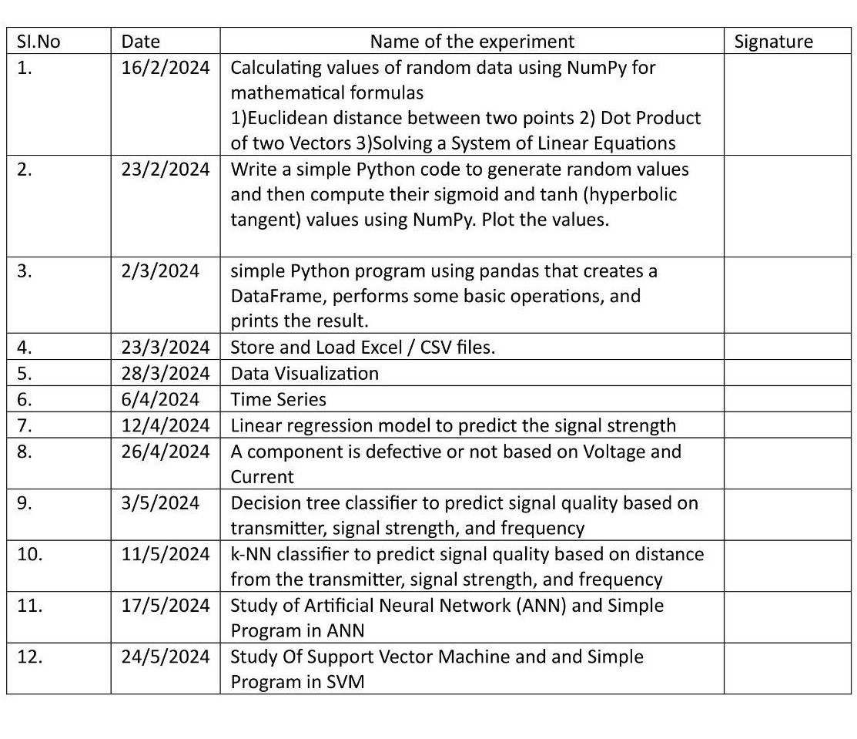

**Ex.no 1 Calculating values of random data using NumPy for 220801143 Date: 16.2.2024 mathematical formulas**

**Aim:**

Calculating values of random data using NumPy for mathematical formulas

1)Euclidean distance between two points 2) Dot Product of two Vectors 3)Solving a System of Linear Equations

**Program:**

#euclidean distance between 2 points point1=np.array([3,2]) point2=np.array([1,1]) d=(((point1[0]-point2[0])**2)+((point1[1]-point2[1])**2)) print(math.sqrt(d))

#dot product def dot(x,y):

dot_prod=x.dot(y) print(dot_prod) dot(point1, point2)

#Linear equation a np.array([[4,3], [5, 9]]) b=np.array([2,1]) print(np.linalg.solve(a,b))

**Output:**

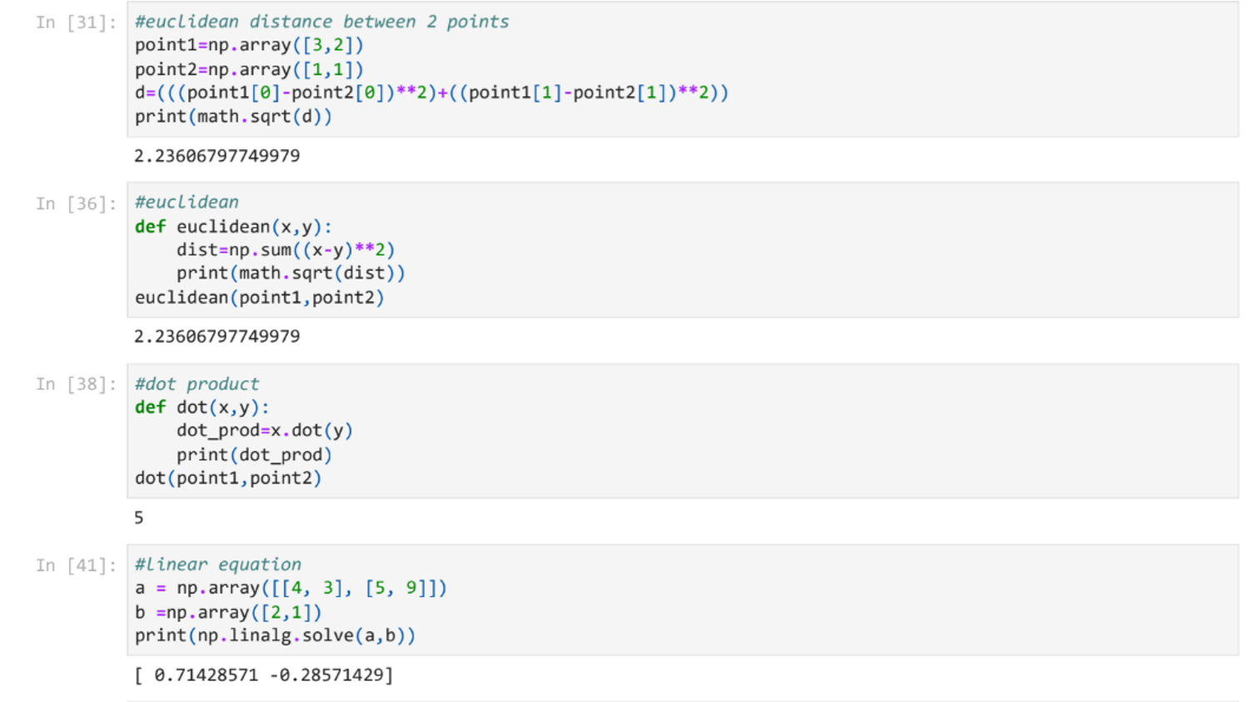

**Result:**

Thus the program has been done and executed and output has been verified successfully.

**Ex.no 2 Sigmoid and Tanh 220801143**

**Date: 23/2/2024**

**Aim:**

Write a simple Python code to generate random values and then compute their sigmoid and tanh (hyperbolic tangent) values using NumPy. Plot the values.

**Program:**

def sigmoid(x):

return 1 / (1 + np.exp(-x))

def tanh(x):

return np.tanh(x)

random_values=np.random.randn(100) sigmoid_values=sigmoid(random_values) tanh_values=tanh(random_values)

#plotting indices=np.arange(len(random_values)) plt.figure(figsize=(14, 6)) plt.subplot(1,2,1) plt.scatter(indices, sigmoid_values, color='r', label='Sigmoid') plt.plot(indices,sigmoid_values,'g',linestyle='-') plt.title('Sigmoid Function') plt.xlabel('Random Values') plt.ylabel('Sigmoid Output') plt.grid() plt.subplot(1,2,2)

plt.scatter(indices, tanh_values, color='b', label='Tanh') plt.plot(indices,tanh_values,'g',linestyle='-') plt.title('Hyperbolic Tangent (tanh) Function') plt.xlabel('Random Values') plt.ylabel('Tanh Output') plt.grid() plt.tight_layout() plt.show()

**Output:**

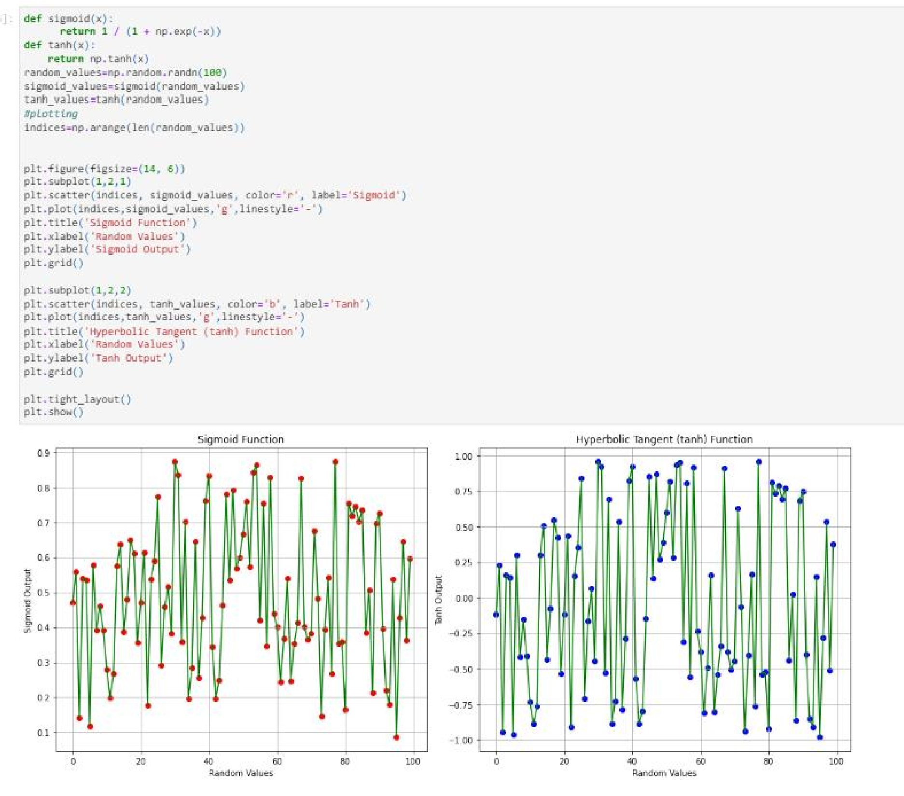

**Result:**

Thus the program has been done and executed and output has been verified successfully.

**Ex.no 3 Simple Program using Pandas 220801143 Date: 2/3/2024**

**Aim:**

Simple Python program using pandas that creates a DataFrame, performs some basic operations, and prints the result.

**Steps:**

1. Imports the pandas library as pd.
2. Creates two lists: data containing fruit names and prices containing their corresponding prices.
3. Zips these lists together and creates a DataFrame named fruits_df with columns named ‘Fruit’ and ‘Price’
4. Uses info() to get information about the DataFrame, including data types and number of entries.
5. Prints the entire DataFrame using to_string().
6. Calculates descriptive statistics (mean, standard deviation, etc.) for the ‘Price’ column and prints the results.

**Program Code:**

import pandas as pd

# Create a list of data data = ["Apple", "Banana", "Cherry", "Orange", "Grape"] prices = [1.25, 0.79, 2.00, 1.50, 0.99]

# Create a DataFrame fruits_df = pd.DataFrame(list(zip(data, prices)), columns=['Fruit', 'Price'])

# Get basic information about the DataFrame print(fruits_df.info())

# Print the DataFrame print(fruits_df.to_string())

# Get descriptive statistics of the 'Price' column print(fruits_df['Price'].describe())

**Output:**

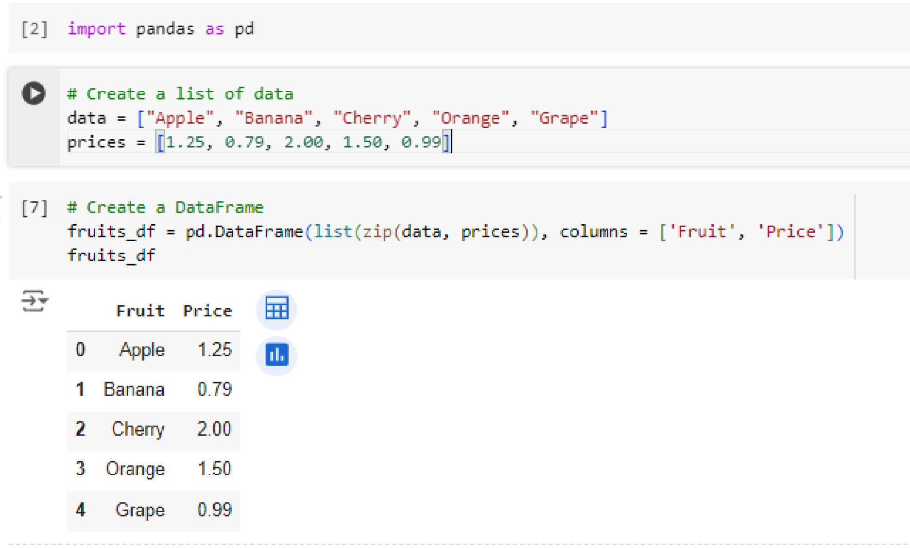

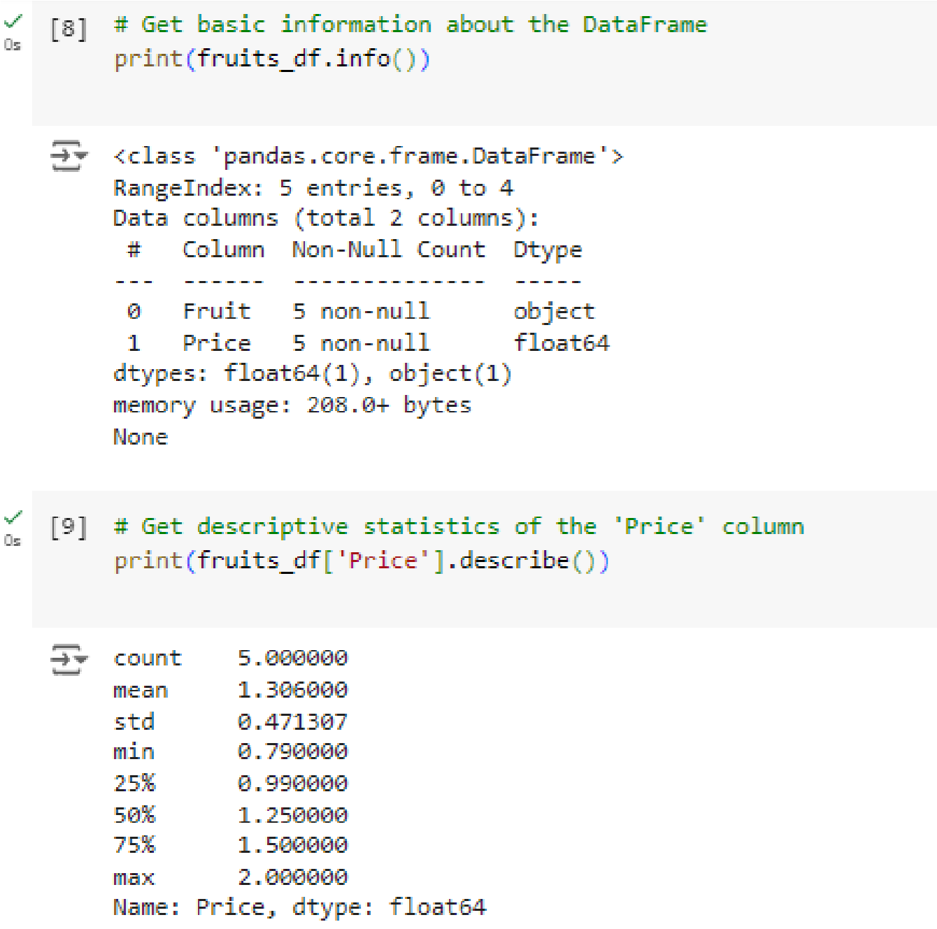

**Result:**

Thus the program has been done and executed and output has been verified successfully.

**Ex.no 4 Store and Load Excel / CSV files. 220801143 Date: 23/3/2024**

**Aim:**

To store (save) and load data from Excel and CSV files using pandas. **Steps:**

**To Store:**

* import pandas as pd.
* Create a sample DataFrame df.
* Use the to_csv function to save the DataFrame to a CSV file.
* ‘people.csv’ is the filename.
* index=True (default) saves the row index as a column. Set it to False to skip it.

**To Load:**

* Import pandas as pd.
* Use read_csv to load data from a CSV file.
* Use read_excel to load data from an Excel file. By default, it reads the first sheet. ● Specify the sheet name with the sheet_name argument for loading data from a specific ● Sheet.

**Program Code:**

**To store:**

import pandas as pd

# Sample data data = {"Name": ["Alice", "Bob", "Charlie"], "Age": [25, 30, 22]} df = pd.DataFrame(data)

# Save to CSV file (with index) df.to_csv("people.csv", index=True)

# Save to CSV file (without index)

df.to_csv("people_no_index.csv", index=False)

**To Load:**

# Load CSV data (assuming it has a header row) df_csv = pd.read_csv(‘people.csv’) print(df_csv)

**Output:**

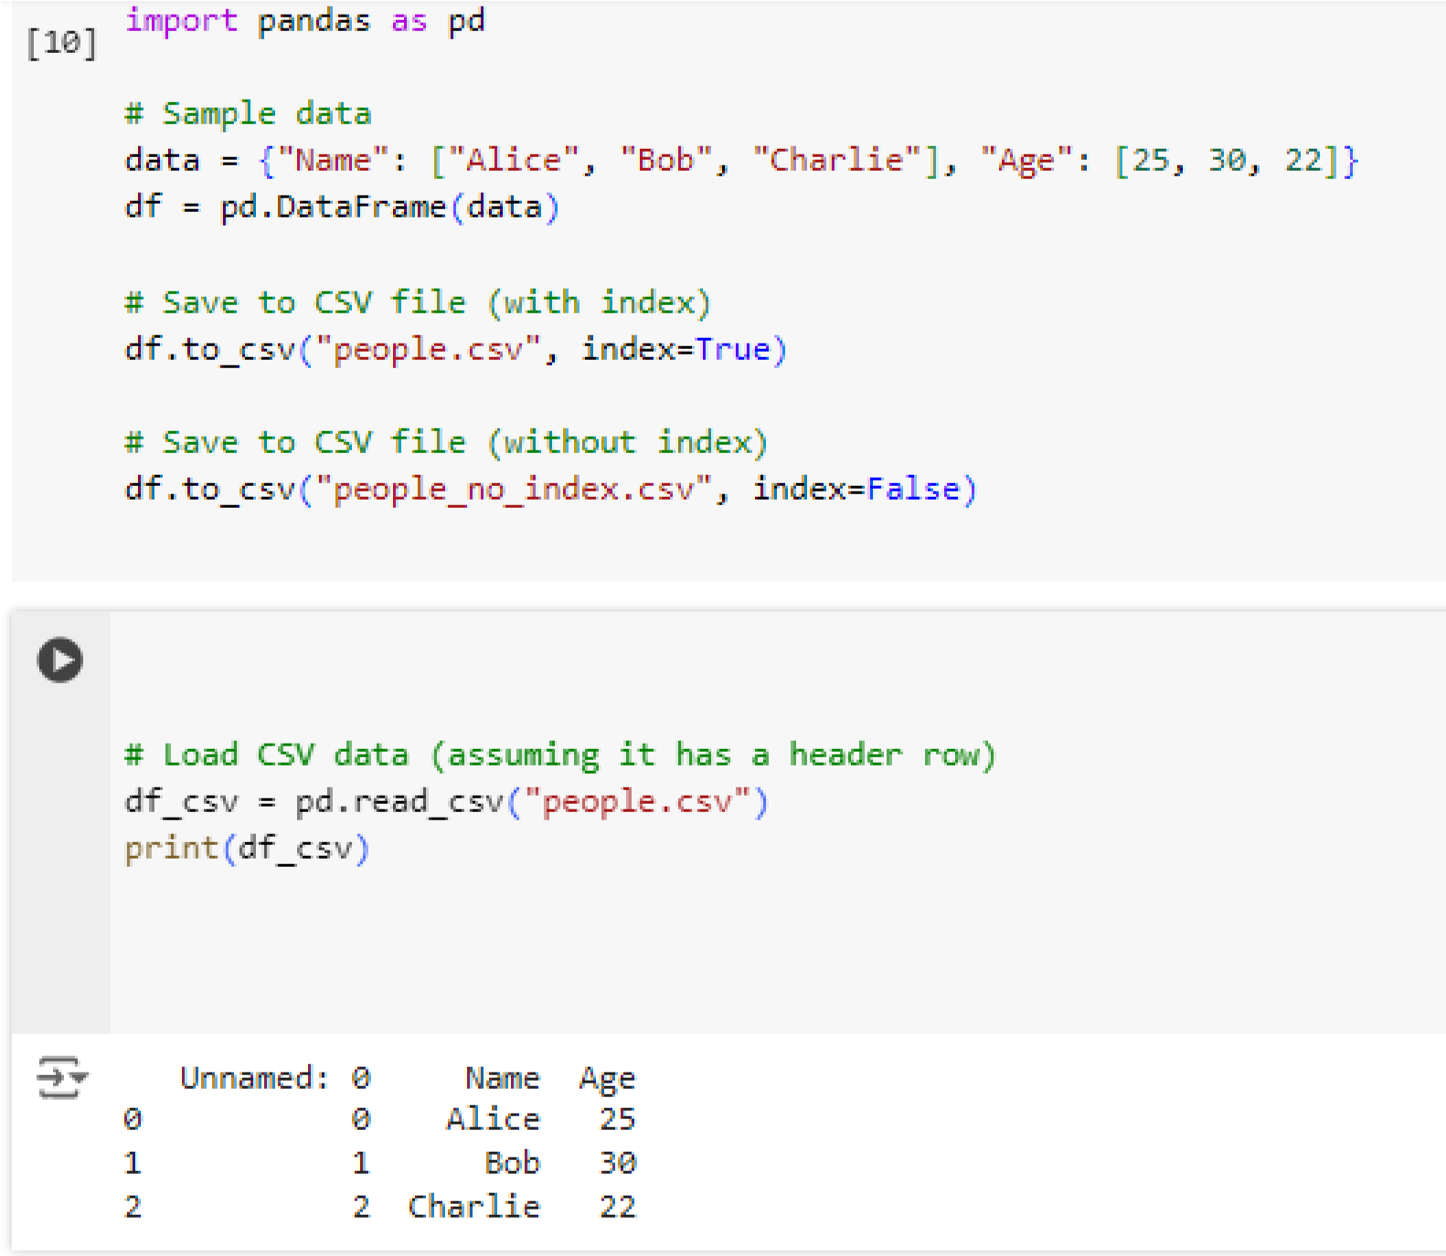

**Ex.no:5 Data Visualization 220801143**

**Date: 28/3/2024**

**Aim:**

To visualize the given data using the matplotlib library in python **Algorithm**:

* Import the matplotlib.pyplot library for plotting.
* Prepare Data
* Use the plt.plot() function to create a line plot with cities on the x-axis and temperatures on the yaxis.
* Customize the plot by adding markers and setting the line style
* Add Labels and Title
* Use plt.show() to display the plot.

**Program:**

import matplotlib.pyplot as plt import pandas as pd # Optional for data manipulation

# Sample data (replace with your data or use pandas to read a CSV) temperatures = [15, 18, 22, 20, 17, 24, 21, 19] cities = ["New York", "Los Angeles", "Chicago", "Denver", "Seattle", "Miami", "Houston", "San Francisco"]

# Line plot plt.plot(cities, temperatures, marker='o', linestyle='-') # Customize markers and line style # Labels and title plt.xlabel("City") plt.ylabel("Temperature (°C)")

plt.title("Average Temperatures in Major US Cities")

# Display the plot plt.xticks(rotation=45) # Rotate city names for better readability

(optional) plt.grid(True) # Add gridlines (optional) plt.show()

**Output:**

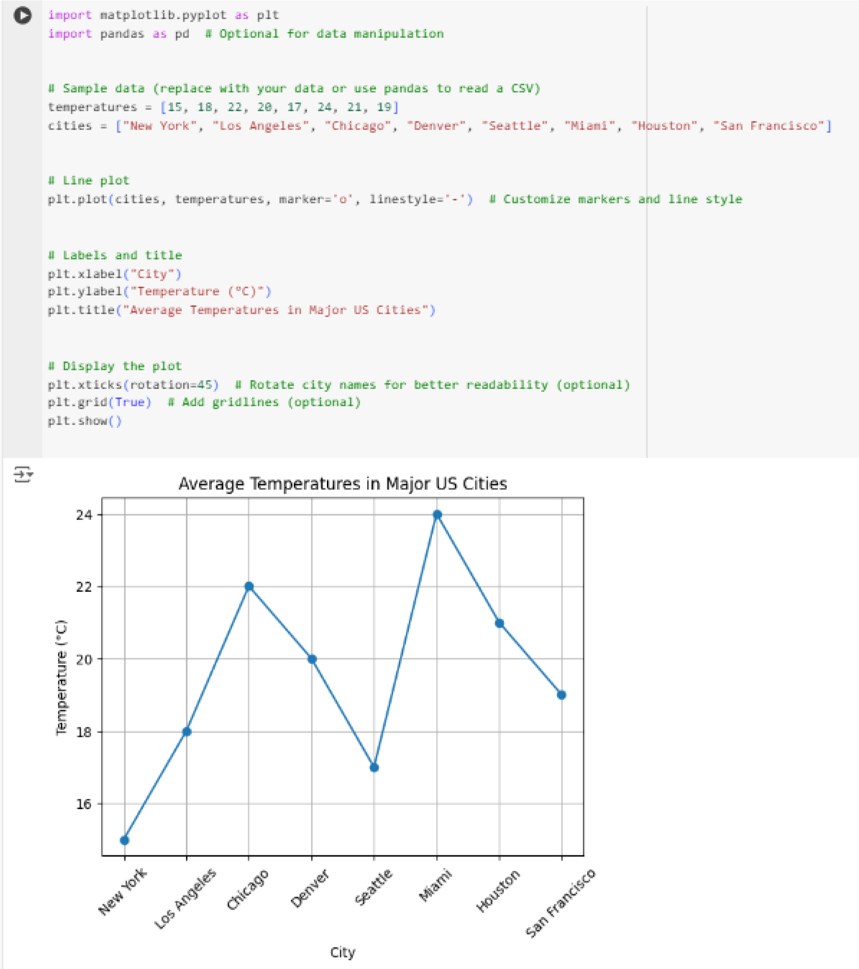

**Ex.no: 7 Time Series 220801143**

**Aim:**

To write a python program to analyze time series data with the help of pandas and matplotlib.

**Algorithm**:

* Import the pandas library for data manipulation ● Import the matplotlib.pyplot library for plotting.
* Create a dictionary data containing the date strings and corresponding values.
* Create a DataFrame df from the dictionary.
* Plot the Time Series:
* Add Labels and Title:
* Use plt.show() to display the plot.
* Calculate Daily Change (Optional):

**Program:**

import pandas as pd

import matplotlib.pyplot as plt

data = {

"Date": pd.to_datetime(["2023-01-01", "2023-02-01", "2023-03-01", "2023-04-01", "2023-05-01"]),

"Value": [100, 120, 135, 110, 145]

}

# Create DataFrame with Date as index df = pd.DataFrame(data).set_index("Date")

# Plot the time series plt.figure(figsize=(10, 6)) # Adjust figure size for better viewing plt.plot(df["Value"], marker='o', linestyle='-') plt.xlabel("Date") plt.ylabel("Value") plt.title("Time Series Data") plt.grid(True) plt.show()

# Calculate daily change (optional)

df["Daily Change"] = df["Value"].diff() # Calculate difference between consecutive values

print(df["Daily Change"].describe())

**Output:**

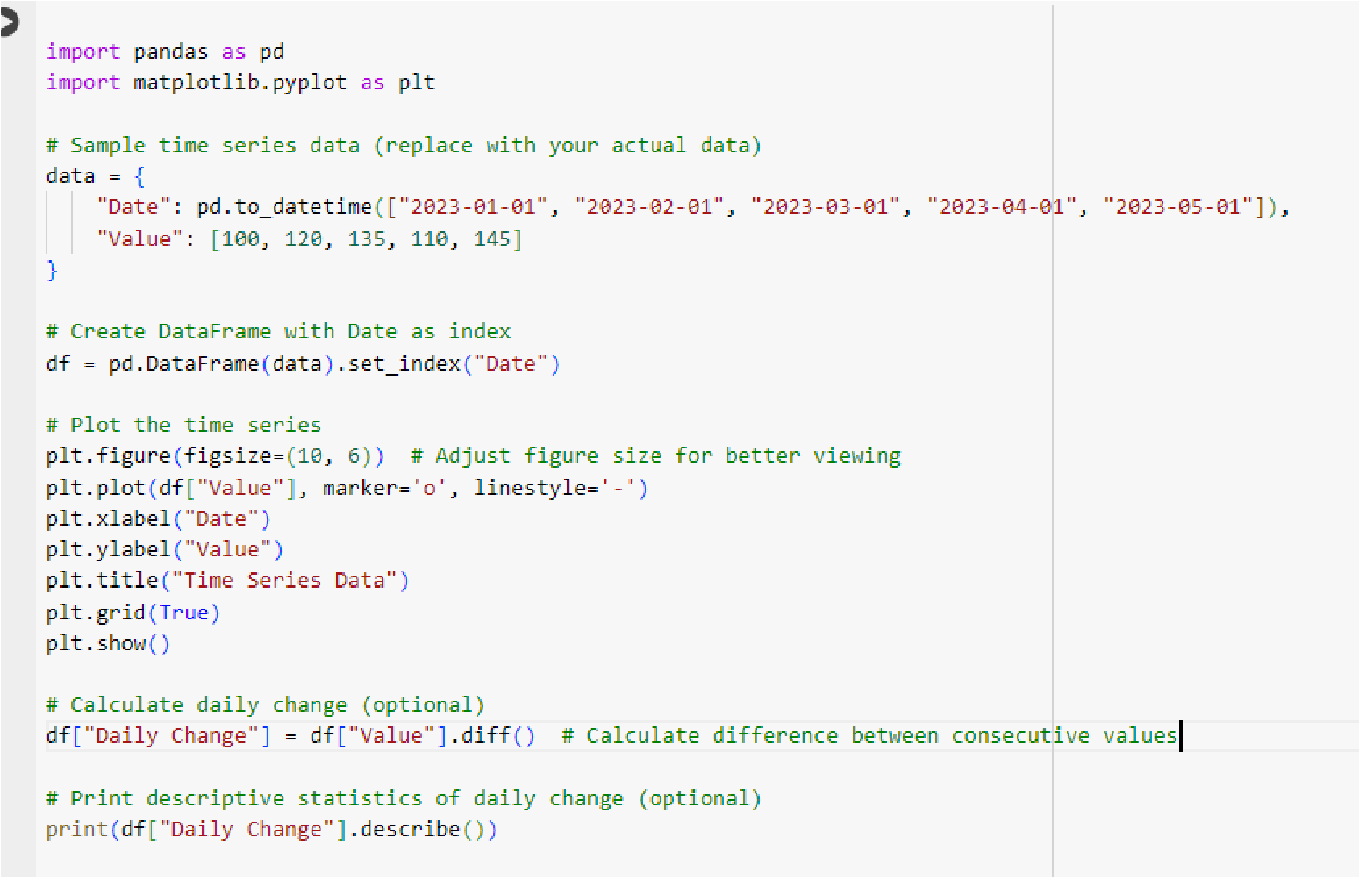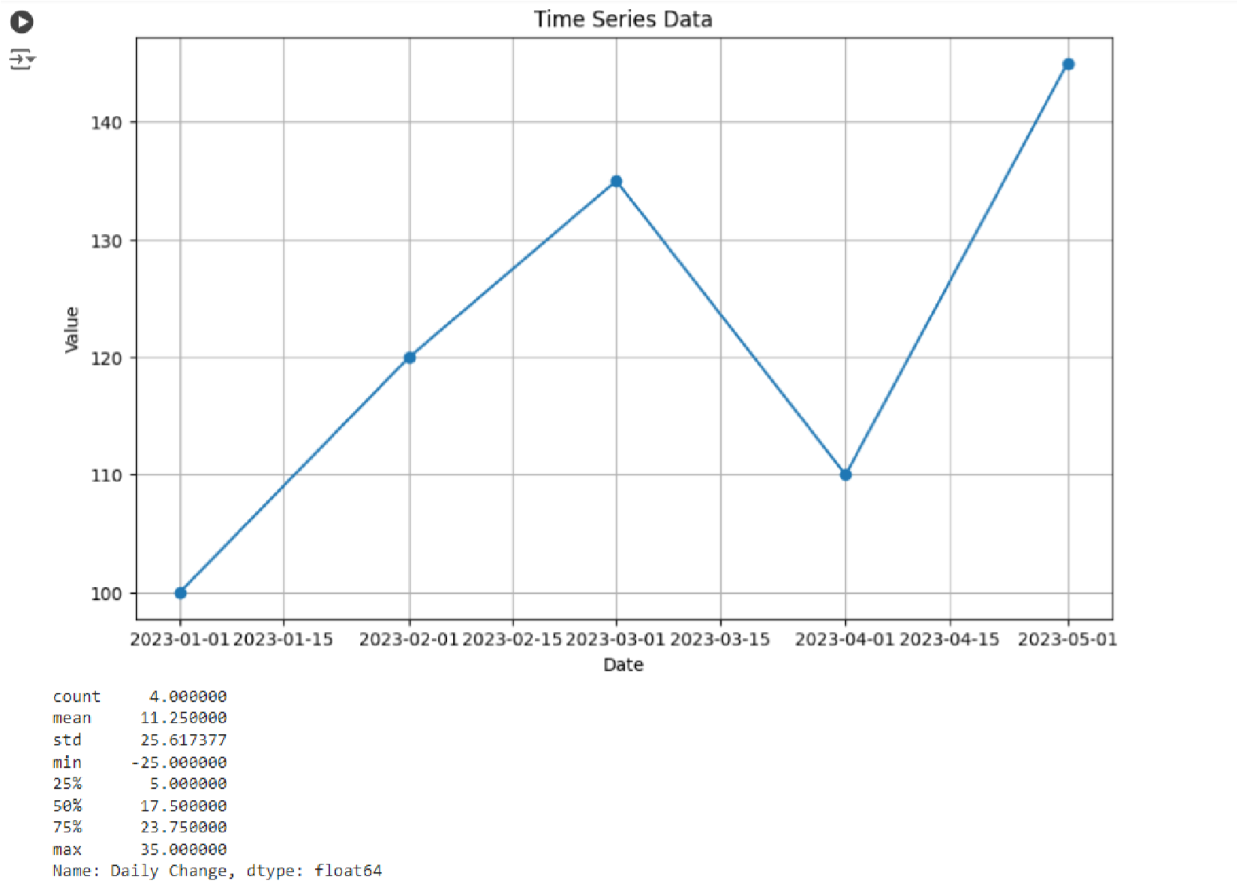

**Ex.no: 8 Linear regression model to predict the signal strength 220801143**

**Date: 26/4/2024 Aim:**

To develop a linear regression model to predict the signal strength based on the distance.

**Problem Statement:**

We have a dataset that records the signal strength (in dBm) at various distances (in meters) from a transmitter. The goal is to develop a linear regression model to predict the signal strength based on the distance.

**Algorithm:**

* Import the necessary libraries
* Prepare the dataset
* Split the dataset into training and testing sets a. Use train_test_split from sklearn.model_selection to split X and y into training and testing sets ● Initialize the linear regression model
* Train the model on the training data.
* Make predictions on the testing data
* Evaluate the model
* Plot the results

**Program:**

import numpy as np import pandas as pd import matplotlib.pyplot as plt

from sklearn.model_selection import train_test_split from sklearn.linear_model import LinearRegression from sklearn.metrics import mean_squared_error, r2_score

# Example dataset: Distance (meters) vs. Signal Strength (dBm) data = {

'Distance': [1, 2, 3, 4, 5, 6, 7, 8, 9, 10],

'Signal_Strength': [-30, -35, -40, -45, -50, -55, -60, -65, -70, -75]

}

# Convert the data into a DataFrame df = pd.DataFrame(data)

# Separate features and target variable X = df[['Distance']].values # Feature: Distance y = df['Signal_Strength'].values # Target: Signal Strength

# Split the data into training and testing sets

X_train, X_test, y_train, y_test = train_test_split(X, y, test_size=0.2, random_state=42)

# Create and train the linear regression model model = LinearRegression() model.fit(X_train, y_train)

# Make predictions

y_pred = model.predict(X_test)

# Evaluate the model mse = mean_squared_error(y_test, y_pred) r2 = r2_score(y_test, y_pred)

print(f'Mean Squared Error: {mse:.2f}') print(f'R^2 Score: {r2:.2f}')

# Visualize the results plt.scatter(X, y, color='blue', label='Actual Data') plt.plot(X, model.predict(X), color='red', label='Fitted Line') plt.xlabel('Distance (meters)') plt.ylabel('Signal Strength (dBm)') plt.title('Linear Regression: Distance vs. Signal Strength') plt.legend() plt.show()

**Output:**

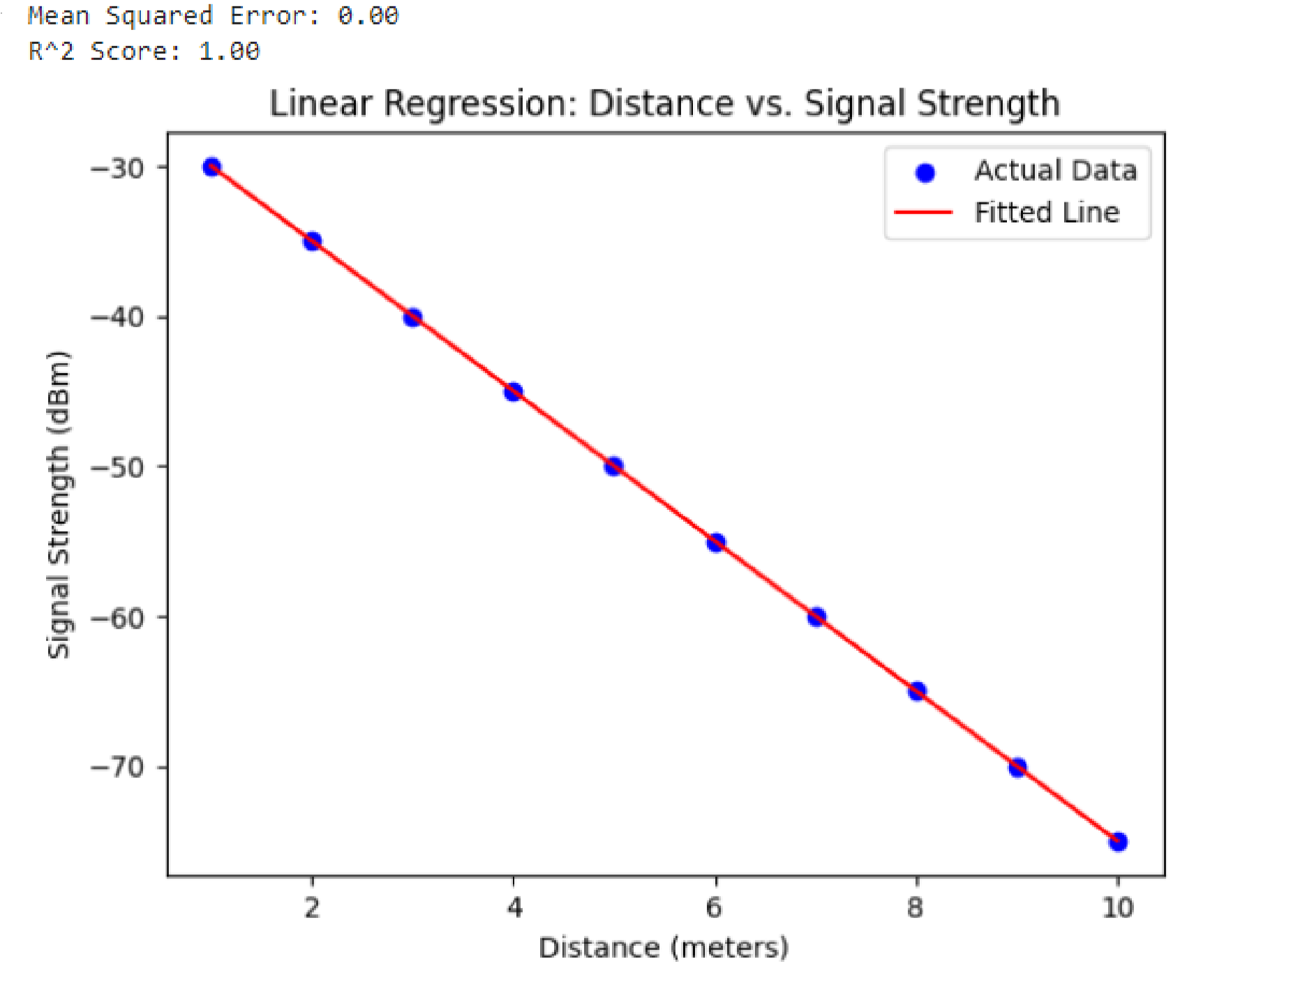

**Result:**

Thus the program has been done and executed and output has been verified successfully.

**Ex.no: 9 Decision tree classifier to predict signal quality based on transmitter, signal strength, and frequency**

**220801143**

**Date: 3/5/2024 Aim:**

Create a simple dataset to classify signal quality based on various parameters such as distance from the transmitter, signal strength, and frequency.

**Problem Statement:**

Dataset that records various parameters affecting the signal quality (Good or Bad). The goal is to develop a decision tree classifier to predict signal quality based on these parameters.

**Algorithm:**

1. Dataset:
   * We create a simple dataset with distance from the transmitter, signal strength, frequency, and corresponding signal qua lity (Good or Bad). The dataset is stored in a dictionary and then converted into a pandas DataFrame.
2. Data Prepa ration:
   * Separate the dataset into features (X) and the target variable (y).
   * Encode the target variable Signal_Quality from categorical values ('Good', 'Bad') to numerical values using LabelEncoder.
3. Model Training:
   * Split the data into training and testing sets using train_test_split.
   * Create an instance of DecisionTreeClassifier and train the model on the training data using the fit method.
4. Prediction and Evaluation:
   * Use the trained model to make predictions on the test data.
   * Calculate the accuracy score and generate a classification report to evaluate the model's performance.
5. Visualization:
   * Visualize the decision tree using plot_tree to understand how the model makes decisions based on the input features.

**Program:**

import numpy as np import pandas as pd import matplotlib.pyplot as plt

from sklearn.model_selection import train_test_split from sklearn.tree import DecisionTreeClassifier, plot_tree from sklearn.metrics import accuracy_score, classification_report # Example dataset: Distance (meters), Signal Strength (dBm), Frequency (MHz) vs. Signal Quality data = {

'Distance': [1, 2, 3, 4, 5, 6, 7, 8, 9, 10, 2, 3, 4, 5, 6],

'Signal_Strength': [-30, -35, -40, -45, -50, -55, -60, -65, -70, -75, -33, -38, 43, -48, -53],

'Frequency': [850, 850, 850, 850, 850, 1900, 1900, 1900, 1900, 1900, 850, 850, 1900, 1900, 1900],

'Signal_Quality': ['Good', 'Good', 'Good', 'Good', 'Bad', 'Bad', 'Bad', 'Bad',

'Bad', 'Bad', 'Good', 'Good', 'Bad', 'Bad', 'Bad']

}

# Convert the data into a DataFrame df = pd.DataFrame(data)

# Separate features and target variable

X = df[['Distance', 'Signal_Strength', 'Frequency']].values # Features y = df['Signal_Quality'].values # Target

# Encode the target variable

from sklearn.preprocessing import LabelEncoder le = LabelEncoder()

y = le.fit_transform(y) # 'Good' -> 1, 'Bad' -> 0

# Split the data into training and testing sets

X_train, X_test, y_train, y_test = train_test_split(X, y, test_size=0.2, random_state=42)

# Create and train the decision tree classifier model = DecisionTreeClassifier(random_state=42) model.fit(X_train, y_train)

# Make predictions

y_pred = model.predict(X_test)

# Evaluate the model

accuracy = accuracy_score(y_test, y_pred) report = classification_report(y_test, y_pred, target_names=['Bad', 'Good'])

print(f'Accuracy: {accuracy:.2f}') print('Classification Report:') print(report)

# Visualize the decision tree plt.figure(figsize=(20,10))

plot_tree(model, feature_names=['Distance', 'Signal_Strength', 'Frequency'], class_names=['Bad', 'Good'], filled=True) plt.show()

**Output:**

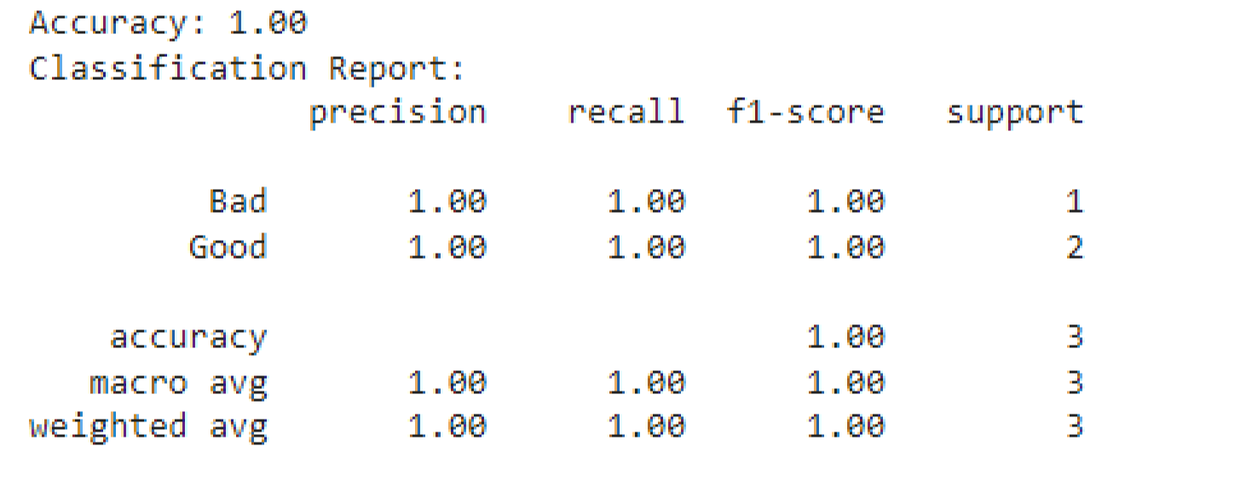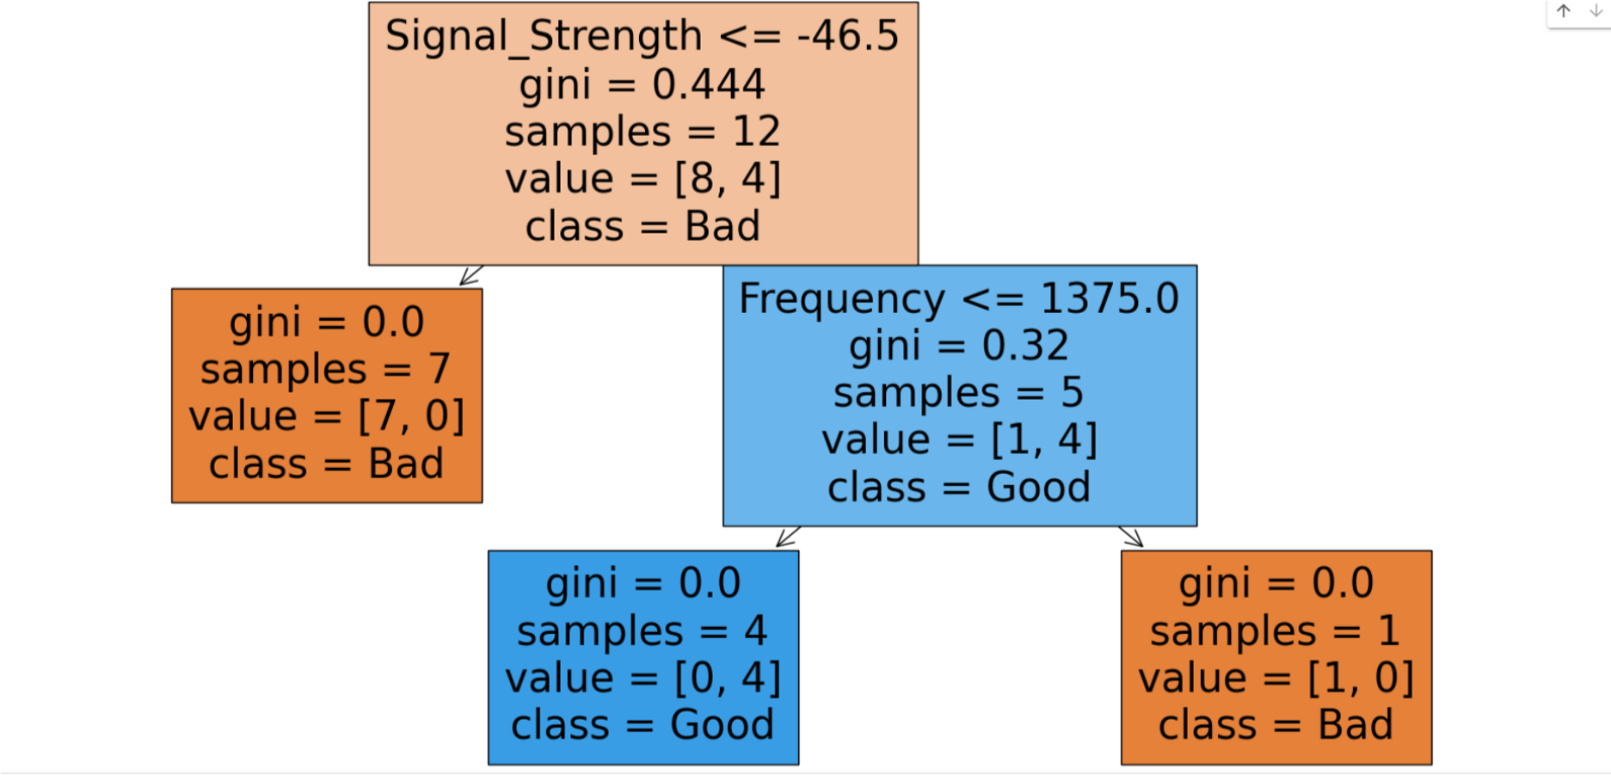

**Result:**

Thus the program has been done and executed and output has been verified successfully.

**Ex.no: 10 k-NN classifier to predict signal quality based on distance from the transmitter, signal strength, and frequency**

**Date: 11/5/2024 220801143**

**Aim:**

To classify signal quality based on various parameters such as distance from the transmitter, signal strength, and frequency. **Prerequisite:**

pip install numpy pandas scikit-learn matplotlib

**Problem Statement**

A dataset that records various parameters affecting the signal quality (Good or Bad). The goal is to develop a k-NN classifier to predict signal quality based on these parameters.

**Algorithm:**

* Import the necessary libraries
* Prepare the dataset
* Split the dataset into training and testing sets a. Use train_test_split from sklearn.model_selection to split X and y into training and testing sets
* Initialize the KNN model
* Train the model on the training data.
* Make predictions on the testing data
* Evaluate the model
* Plot the results

**Program:**

import numpy as np import pandas as pd import matplotlib.pyplot as plt

from sklearn.model_selection import train_test_split from sklearn.neighbors import KNeighborsClassifier from sklearn.preprocessing import StandardScaler

from sklearn.metrics import accuracy_score, classification_report, confusion_matrix import seaborn as sns

# Example dataset: Distance (meters), Signal Strength (dBm), Frequency (MHz) vs. Signal Quality data = {

'Distance': [1, 2, 3, 4, 5, 6, 7, 8, 9, 10, 2, 3, 4, 5, 6],

'Signal_Strength': [-30, -35, -40, -45, -50, -55, -60, -65, -70, -75, -33, -38, -

43, -48, -53],

'Frequency': [850, 850, 850, 850, 850, 1900, 1900, 1900, 1900, 1900, 850, 850,

1900, 1900, 1900],

'Signal_Quality': ['Good', 'Good', 'Good', 'Good', 'Bad', 'Bad', 'Bad', 'Bad', 'Bad', 'Bad', 'Good', 'Good', 'Bad', 'Bad', 'Bad']

}

# Convert the data into a DataFrame df = pd.DataFrame(data)

# Separate features and target variable

X = df[['Distance', 'Signal_Strength', 'Frequency']].values # Features y = df['Signal_Quality'].values # Target

# Encode the target variable from sklearn.preprocessing import LabelEncoder le = LabelEncoder() y = le.fit_transform(y) # 'Good' -> 1, 'Bad' -> 0

# Split the data into training and testing sets

X_train, X_test, y_train, y_test = train_test_split(X, y, test_size=0.2, random_state=42)

# Standardize the features scaler = StandardScaler()

X_train = scaler.fit_transform(X_train)

X_test = scaler.transform(X_test)

# Create and train the k-NN classifier k = 3 # Number of neighbors model = KNeighborsClassifier(n_neighbors=k) model.fit(X_train, y_train)

# Make predictions

y_pred = model.predict(X_test)

# Evaluate the model

accuracy = accuracy_score(y_test, y_pred)

report = classification_report(y_test, y_pred, target_names=['Bad', 'Good'])

print(f'Accuracy: {accuracy:.2f}') print('Classification Report:') print(report)

# Confusion Matrix

conf_matrix = confusion_matrix(y_test, y_pred)

sns.heatmap(conf_matrix, annot=True, fmt='d', cmap='Blues', xticklabels=['Bad', 'Good'], yticklabels=['Bad', 'Good'])

plt.xlabel('Predicted') plt.ylabel('Actual') plt.title('Confusion Matrix') plt.show()

**Output:**

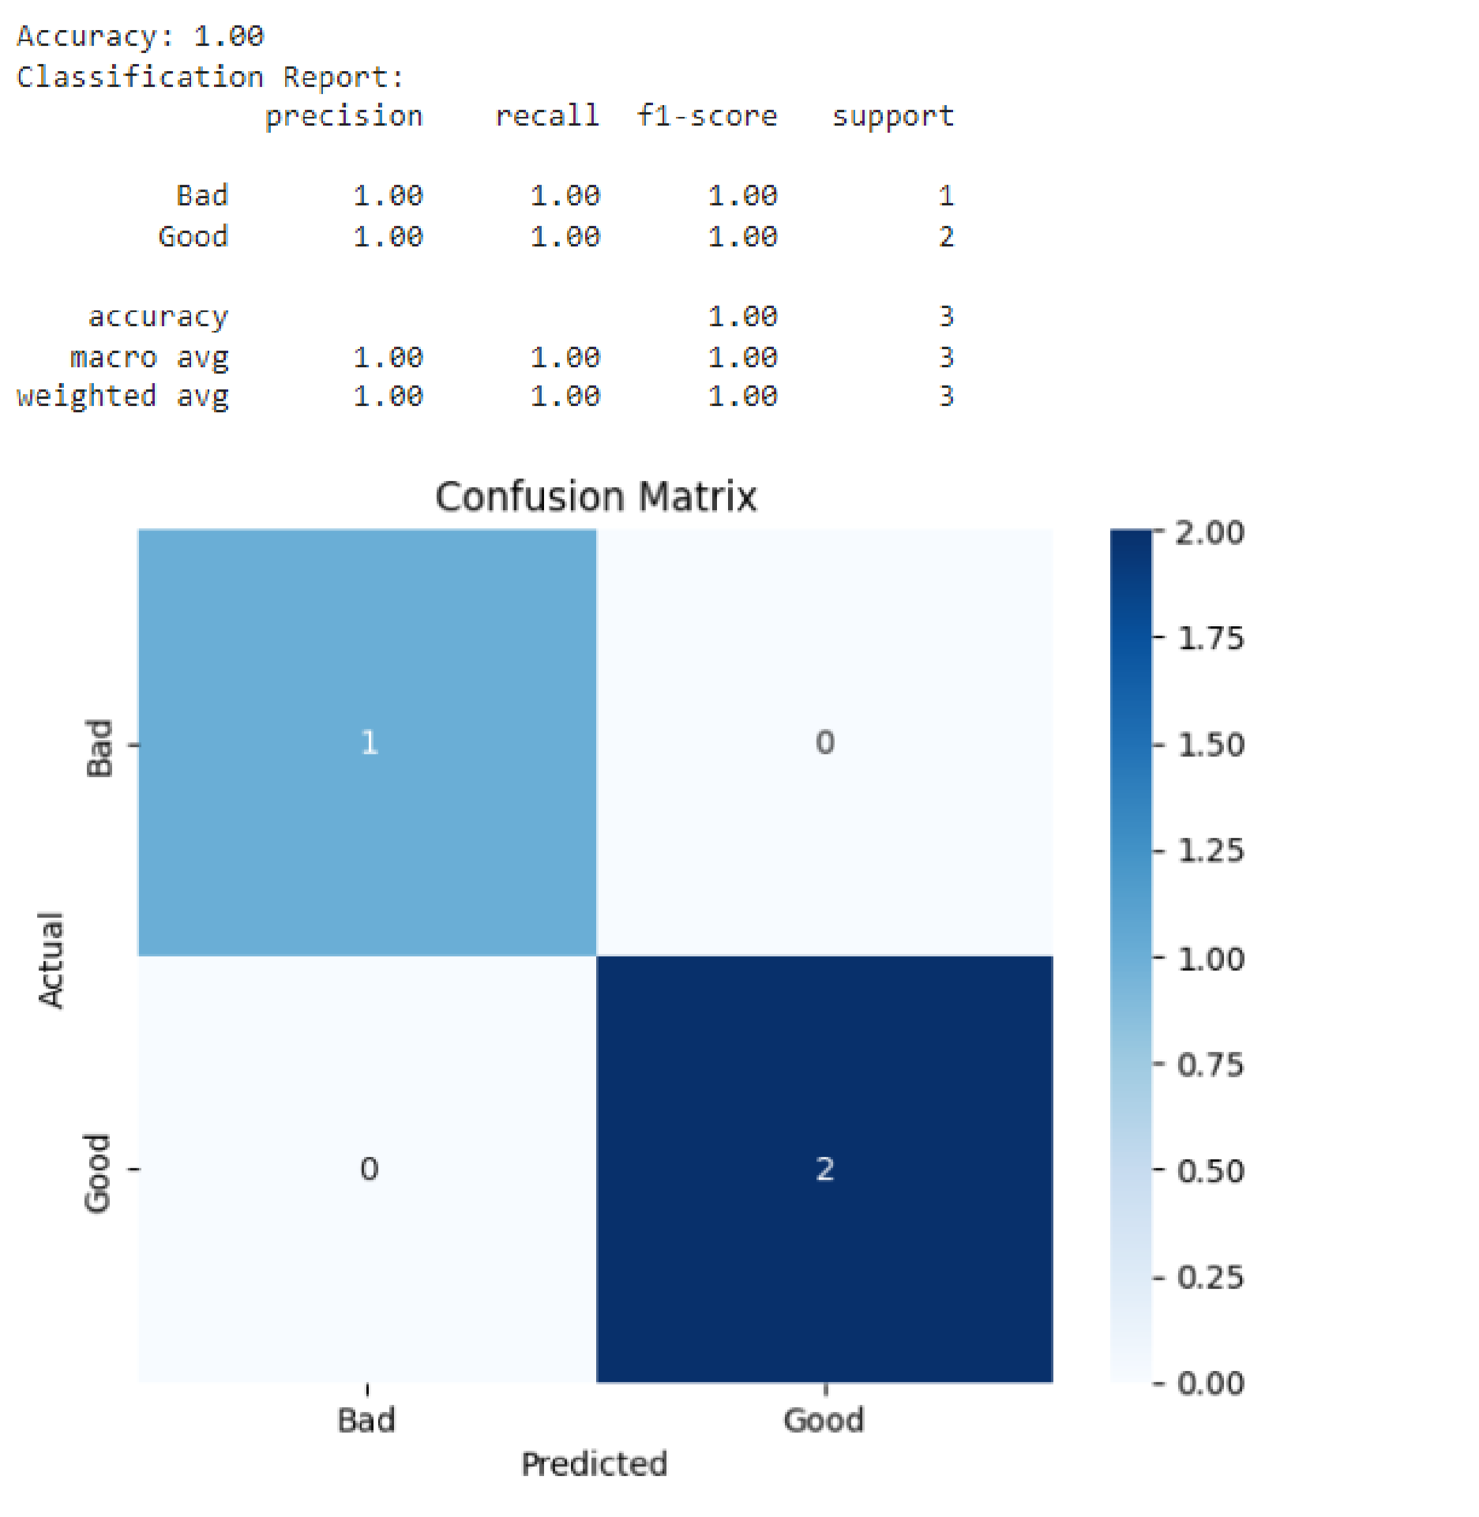

**Result:**

Thus the program has been done and executed and output has been verified successfully.

**Ex.no: 11 Study of Artificial Neural Network (ANN) and Simple Program in ANN 220801143 Date: 17/5/2024**

**Aim:**

To study Artificial Neural Network (ANN) using a simple program in ANN **Prerequisite:**

pip install numpy scikit-learn

**Algorithm:**

* Import the necessary libraries
* Prepare the dataset
* Split the dataset into training and testing sets a. Use train_test_split from sklearn.model_selection to split X and y into training and testing sets ● Initialize the neural network model
* Train the model on the training data.
* Make predictions on the testing data
* Evaluate the model
* Plot the results

**Program:**

import numpy as np from sklearn import datasets from sklearn.model_selection import train_test_split from sklearn.preprocessing import StandardScaler from sklearn.neural_network import MLPClassifier

from sklearn.metrics import classification_report, accuracy_score

iris = datasets.load_iris() X = iris.data y = iris.target

X_train, X_test, y_train, y_test = train_test_split(X, y, test_size=0.3, random_state=42)

scaler = StandardScaler()

X_train = scaler.fit_transform(X_train)

X_test = scaler.transform(X_test)

# We'll use a Multi-layer Perceptron classifier mlp = MLPClassifier(hidden_layer_sizes=(10,), max_iter=1000, random_state=42) mlp.fit(X_train, y_train)

y_pred = mlp.predict(X_test)

print("Classification Report:") print(classification_report(y_test, y_pred)) print("Accuracy:", accuracy_score(y_test, y_pred))

**Output:**

Classification Report:

Precision recall f1-score support

1. 1.00 1.00 1.00 19
2. 1.00 1.00 1.00 13
3. 1.00 1.00 1.00 13

accuracy 1.00 45 macro avg 1.00 1.00 1.00 45 weighted avg 1.00 1.00 1.00 45

Accuracy: 1.0

**Result:**

Thus the program has been done and executed and output has been verified successfully.

**Ex. No: 12 Study Of Support Vector Machine and and Simple Program in SVM 220801143 Date: 24/5/2024 Aim:**

To demonstrate the application of SVM for classification, showcasing its strengths in handling high-dimensional spaces and providing a clear understanding of its working mechanism.

**Prerequisite:**

pip install scikit-learn

**Algorithm:**

* Import the necessary libraries
* Prepare the dataset
* Split the dataset into training and testing sets a. Use train_test_split from sklearn.model_selection to split X and y into training and testing sets
* Initialize SVC model
* Train the model on the training data.
* Make predictions on the testing data
* Evaluate the model
* **Program:**

from sklearn import datasets from sklearn.model_selection import train_test_split from sklearn.svm import SVC

from sklearn.metrics import accuracy_score

iris = datasets.load_iris() X = iris.data y = iris.target

X_train, X_test, y_train, y_test = train_test_split(X, y, test_size=0.3, random_state=42)

clf = SVC(kernel=’linear’, C=1) clf.fit(X_train, y_train)

y_pred = clf.predict(X_test)

accuracy = accuracy_score(y_test, y_pred) print(‘Accuracy: {accuracy:.2f}’)

**Output**:

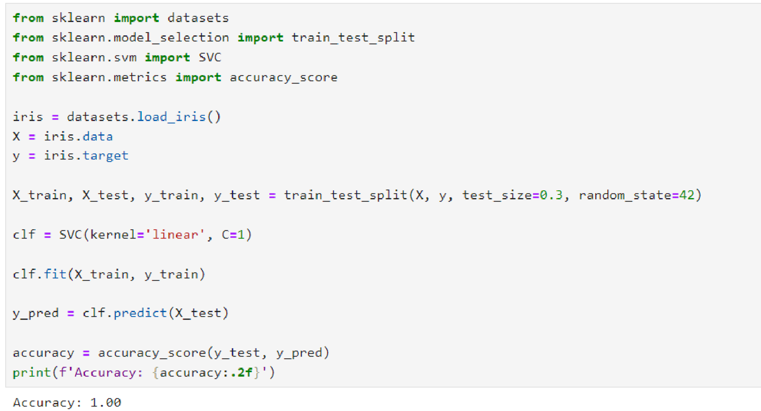

**Result:**

Thus the program has been done and executed and output has been verified successfully.